RESUME

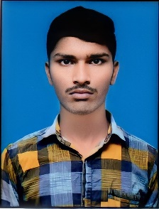**RAMDHAN PRAJAPAT**

**Email Id:** [ramdhanprajapat26@gmail.com](mailto:ramdhanprajapat26@gmail.com)

**Mobile:** +91 8505019604

**Address:** ward no. 13,Dudhwa Khara, Churu,Rajasthan

331029.

**Objective:**

Seeking innovative and challenging career in a growing organization which gives me an opportunity to utilize my skills & knowledge and provides me an opportunity for career growth.

# Academic Profile:

|  |  |  |  |
| --- | --- | --- | --- |
| **Qualification** | **Institution** | **Year of Passing** | **PERCENT** |
| **M.Sc. Mathematics & Computing** | **Indian Institute of Technology Indian School of Mines Dhanbad** | **2025** | **Pursing** |
| B.Sc. | Shekhawati University, Sikar | 2022 | 85.18% |
| Intermediate | Guru Ravindranath Tagore S.S. School, Taranagar,  Churu | 2019 | 91.80% |
| 10th Class | D.A.V. School, Dudhwa Khara, Churu | 2017 | 84.67% |

# Technical Skill:

* Programming language – C/C++, Python
* Libraries – NumPy, Pandas, Matplotlib, Seaborn

# Soft Skills:

* Good communication skills
* Problem solving
* Ability to work independently

# Personal Information

Father’s name : Om Prakash Prajapat

Date of birth : 08 March, 2001 Gender : Male

Nationality : Indian

Languages Known : English & Hindi

Place: Dudhwa khara

Date: 06 October 2023 Ramdhan